

**PRACTICAL JOURNAL**

Enrollment Number – 2019BTCS088 Year of Enrollment – 2019

Name of the Student – YASH GUPTA

School of COMPUTER SCIENCE & INFORMATION TECHNOLOGY

Program – B. TECH

Specialization/ Branch – CS&IT

Semester – 4TH Section – B2 Branch – CS&IT

Paper Code – BTCS03CCB5 Name of Paper – Mobile Application Development

Faculty-In-Charge – MR. DEEPAK YADAV SIR

CERTIFICATE

THE PRACTICAL EXPERIMENTS

ENTERED IN THIS JOURNAL HAVE BEEN SATISFACTORY PERFORMED BY

ENROLLMENT NO - 2019BTCS088 MR/MS­­­­­­­­­­­­­­­­­­­­ YASH GUPTA

STUDYING IN PROGRAM B. TECH BRANCH CS&IT IN

SCHOOL OF COMPUTER SCIENCE & INFORMATION TECHNOLOGY

DURING SEMESTER 4TH OF ACADEMIC YEAR 2020-2021

_______________________

(Faculty In charge)

Date: _________________

INDEX

|  |  |  |  |  |
| --- | --- | --- | --- | --- |
| S.NO | Title of Skill Activity | Date of Allocation | Date of Submission | Sign of Faculty |
| 1 | Install Java, configure Android development framework (Android Studio). | 10/05/2021 | 11/05/2021 |  |
|  |  |  |  |  |
| 2. | Create Android Virtual Devices (Pixel 4 or any other). | 14/05/2021 | 15/05/2021 |  |
|  |  |  |  |  |
| 3. | Create an Android App to demonstrate implicit and explicit intent calling. | 17/05/2021 | 18/05/2021 |  |
|  |  |  |  |  |
| 4. | Design an Android App to demonstrate GridLayout, with at least 6 components (textbox, button ...) | 21/05/2021 | 25/05/2021 |  |
|  |  |  |  |  |
| 5. | Create an Android app to demonstrate spinner functionality | 18/06/2021 | 21/06/2021 |  |
|  |  |  |  |  |
|  |  |  |  |  |
|  |  |  |  |  |
|  |  |  |  |  |
|  |  |  |  |  |
|  |  |  |  |  |
|  |  |  |  |  |
|  |  |  |  |  |
|  |  |  |  |  |
|  |  |  |  |  |
|  |  |  |  |  |
|  |  |  |  |  |
|  |  |  |  |  |
|  |  |  |  |  |
|  |  |  |  |  |
|  |  |  |  |  |
|  |  |  |  |  |

Practical No: 01  
(To be filled by the students)

Date: 10th May 2021

**Assessment Parameters (To be filled by faculty)**

1. **Successful completion of Practical (Y/N)**
2. **Time taken (hours/ minutes)**
3. **List other Parameters & Outcomes:**

|  |  |  |
| --- | --- | --- |
| **S.No.** | **Parameters** | **Outcomes**  **(Achieved / Not Achieved)** |
|  |  |  |
|  |  |  |
|  |  |  |
|  |  |  |
|  |  |  |
|  |  |  |
|  |  |  |
|  |  |  |
|  |  |  |
|  |  |  |

**Remarks:**

# ANdroid studio installation:

1. Downloading JDK from official Website.  
   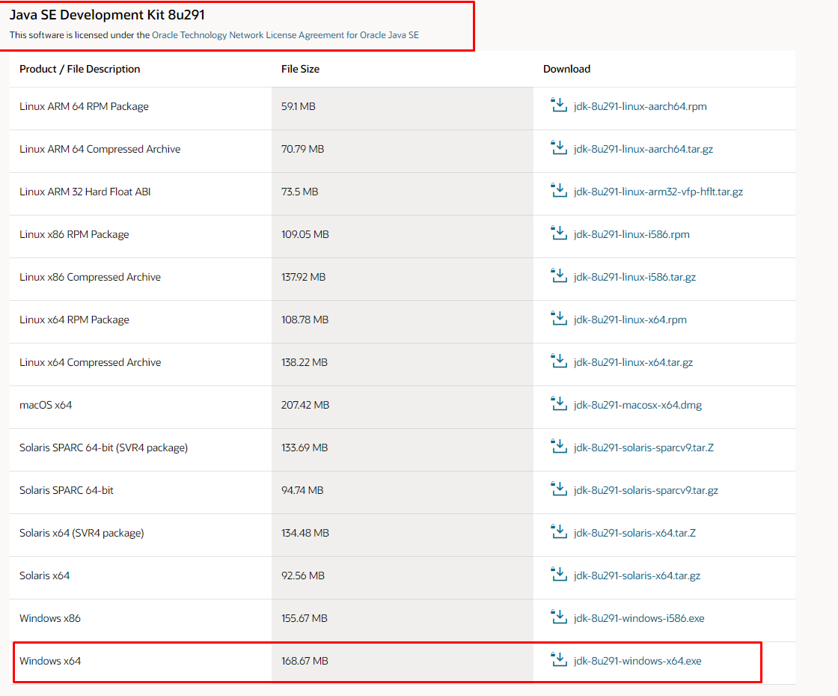
2. Installing JDK in our System.  
   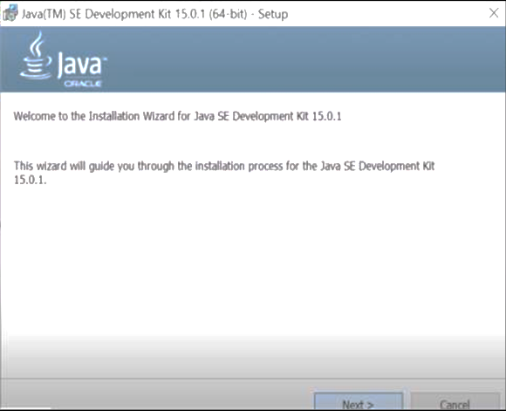
3. Java installed successfully.

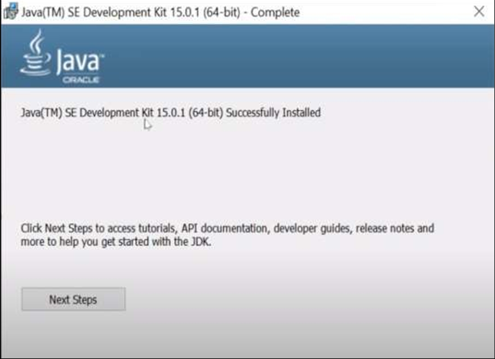

1. Verification of JDK installation via CMD Prompt.  
   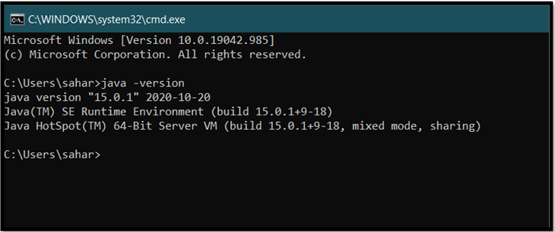
2. Downloading Android Studio from official website.  
   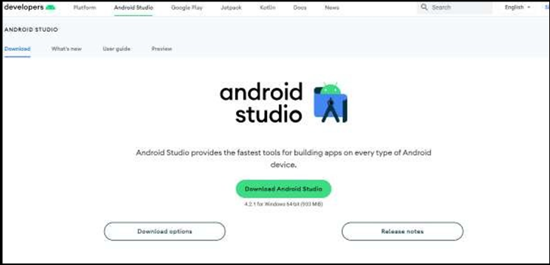
3. Running the Android Studio for installation.  
   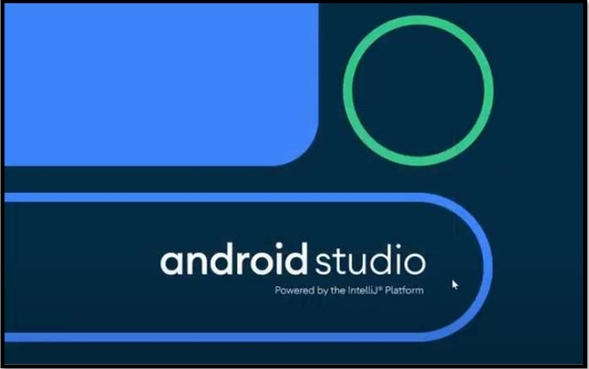
4. Selecting install type for Android Studio installation from Installation Wizard.  
   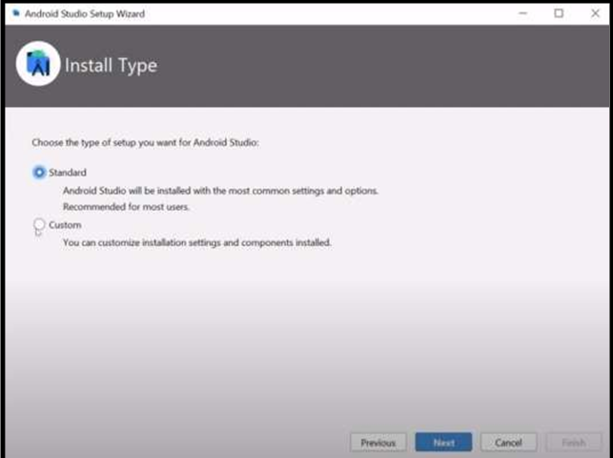
5. Finally, we can use Android Studio.  
   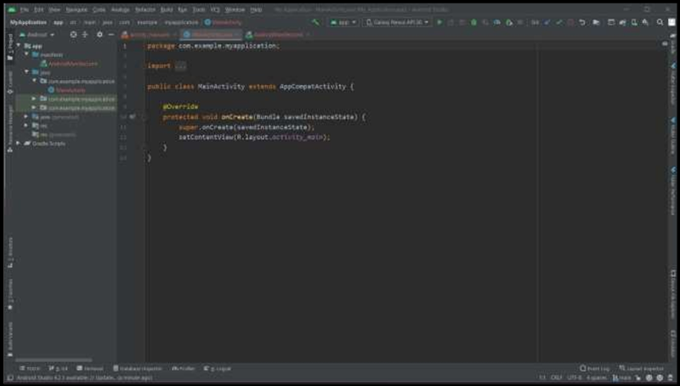

Practical No: 02  
(C# Program for finding speed in different units)

Date: 23rd June 2021

**Assessment Parameters (To be filled by faculty)**

1. **Successful completion of Practical (Y/N)**
2. **Time taken (hours/ minutes)**
3. **List other Parameters & Outcomes:**

|  |  |  |
| --- | --- | --- |
| **S.No.** | **Parameters** | **Outcomes**  **(Achieved / Not Achieved)** |
|  |  |  |
|  |  |  |
|  |  |  |
|  |  |  |
|  |  |  |
|  |  |  |
|  |  |  |
|  |  |  |
|  |  |  |
|  |  |  |

**Remarks:**

**Total marks __________ out of 10. Sign of Faculty**

# source code:

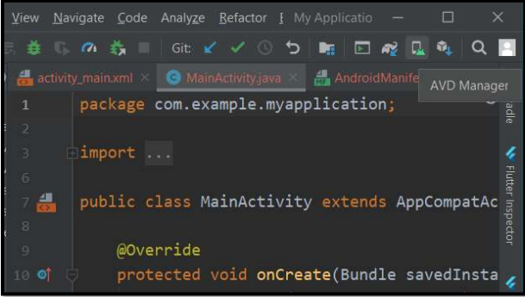  
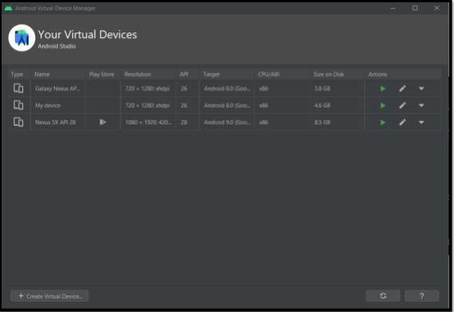

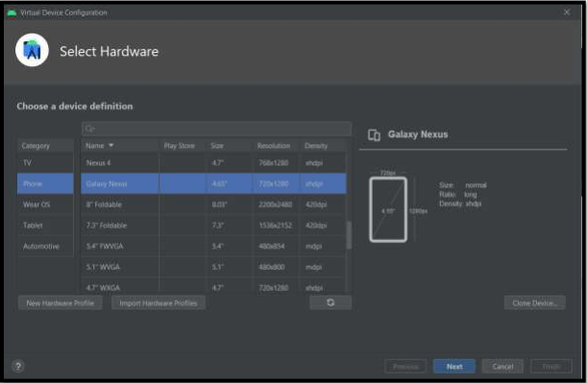

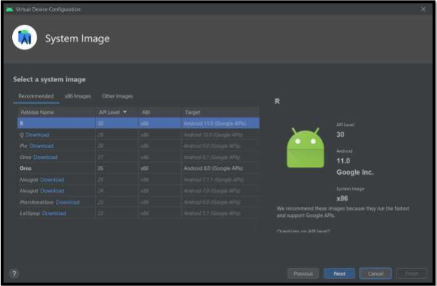

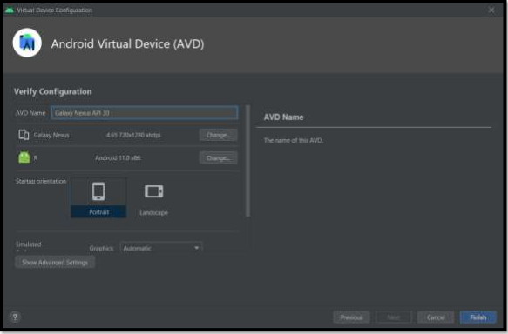

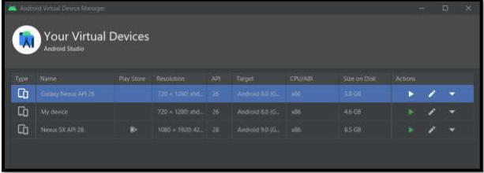

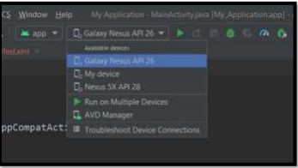

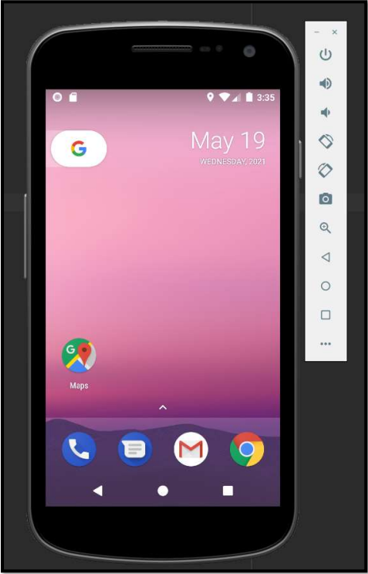  
-------------------------------------------------------------------------------------

Practical No: 03  
(C# Program for creating Master Page)

Date: 23rd June 2021

**Assessment Parameters (To be filled by faculty)**

1. **Successful completion of Practical (Y/N)**
2. **Time taken (hours/ minutes)**
3. **List other Parameters & Outcomes:**

|  |  |  |
| --- | --- | --- |
| **S.No.** | **Parameters** | **Outcomes**  **(Achieved / Not Achieved)** |
|  |  |  |
|  |  |  |
|  |  |  |
|  |  |  |
|  |  |  |
|  |  |  |
|  |  |  |
|  |  |  |
|  |  |  |
|  |  |  |

**Remarks:**

**Total marks __________ out of 10. Sign of Faculty**

# implicit intent:

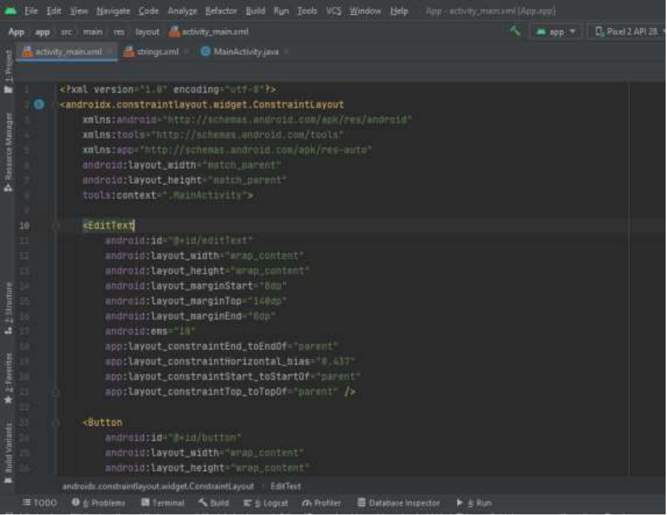

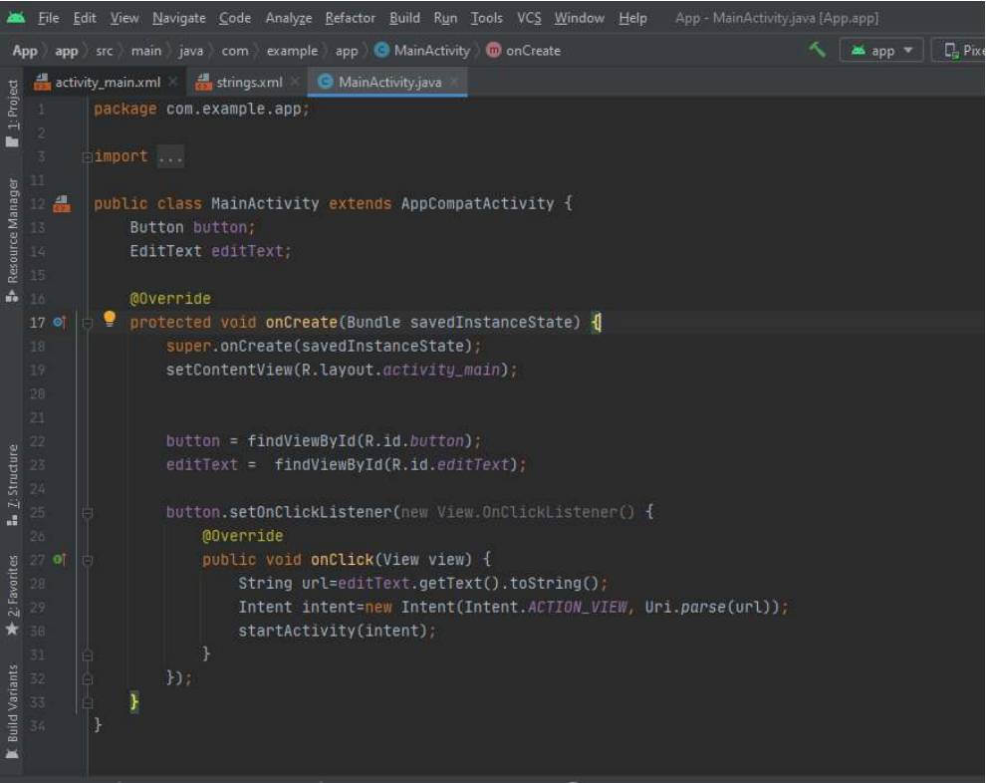

# output of IMPLicit intent:

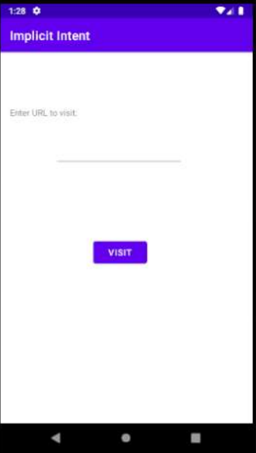

# EXPLicit intent:

**File Name: activity_main.xml**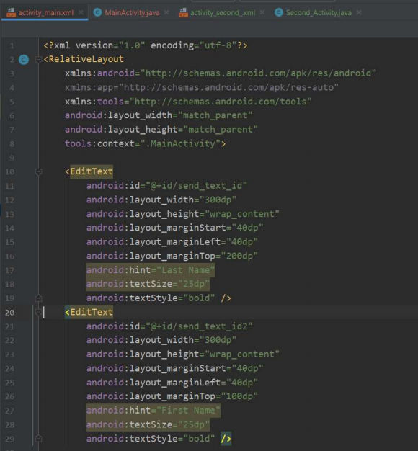

**File Name: MainActivity.java**

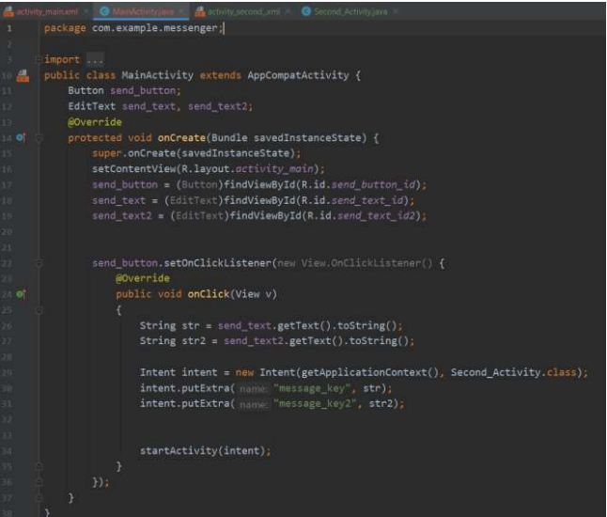

**File Name: activity_second_.xml**

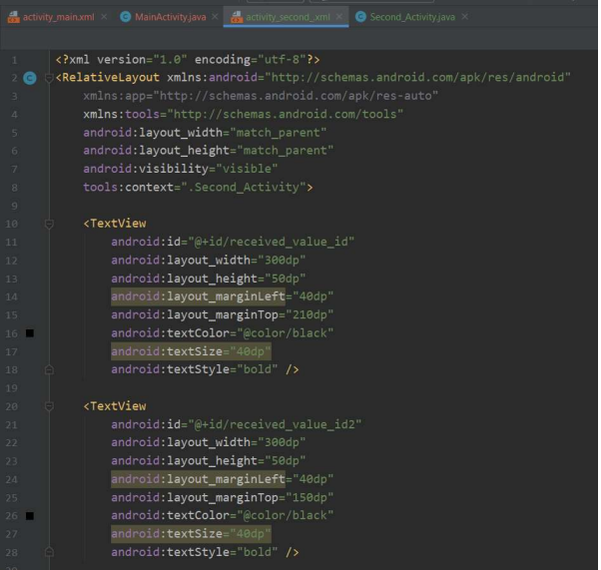

**File Name: SecondActivity.java**

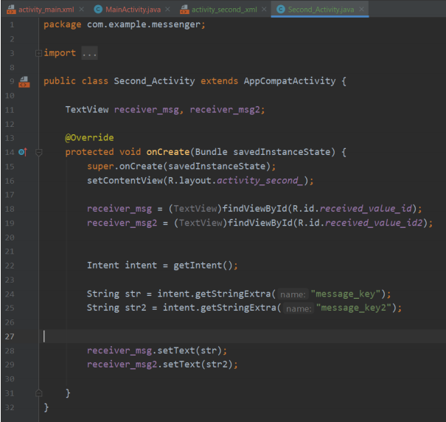

# Output of EXPLicit intent:

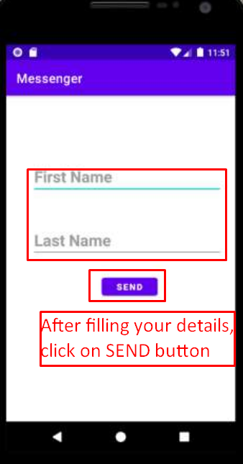------------------------------------------------------------------------------------

Practical No: 04  
(C# Program for Creating Registration Form with Validation Control)

Date: 23rd June 2021

**Assessment Parameters (To be filled by faculty)**

1. **Successful completion of Practical (Y/N)**
2. **Time taken (hours/ minutes)**
3. **List other Parameters & Outcomes:**

|  |  |  |
| --- | --- | --- |
| **S.No.** | **Parameters** | **Outcomes**  **(Achieved / Not Achieved)** |
|  |  |  |
|  |  |  |
|  |  |  |
|  |  |  |
|  |  |  |
|  |  |  |
|  |  |  |
|  |  |  |
|  |  |  |
|  |  |  |

**Remarks:**

**Total marks __________ out of 10. Sign of Faculty**

# Grid layout:

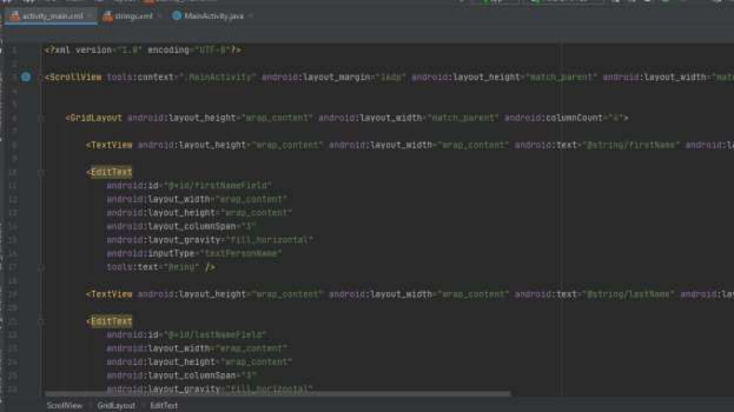

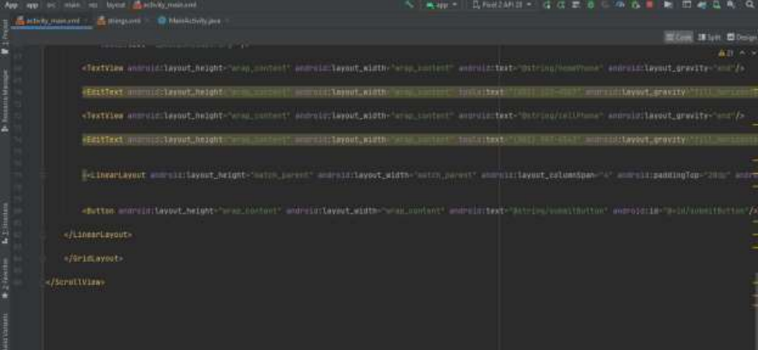

# output of grid layout:

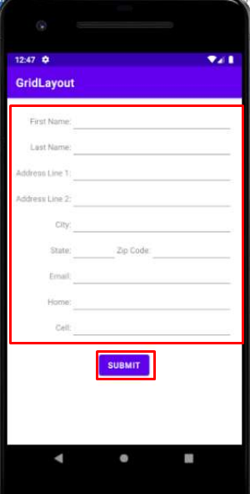

------------------------------------------------------------------------------------

Practical No: 05  
(C# Program for demonstrating use of Session)

Date: 23rd June 2021

**Assessment Parameters (To be filled by faculty)**

1. **Successful completion of Practical (Y/N)**
2. **Time taken (hours/ minutes)**
3. **List other Parameters & Outcomes:**

|  |  |  |
| --- | --- | --- |
| **S.No.** | **Parameters** | **Outcomes**  **(Achieved / Not Achieved)** |
|  |  |  |
|  |  |  |
|  |  |  |
|  |  |  |
|  |  |  |
|  |  |  |
|  |  |  |
|  |  |  |
|  |  |  |
|  |  |  |

**Remarks:**

**Total marks __________ out of 10. Sign of Faculty**

# camera access in android studio:

**File Name: MainActivity.java**

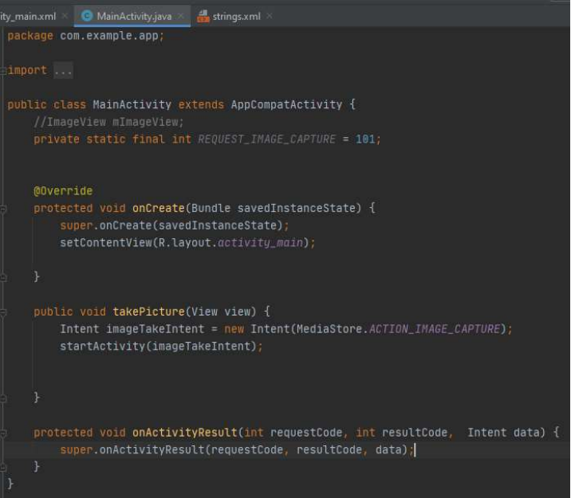

**File Name: activity_main.xml**

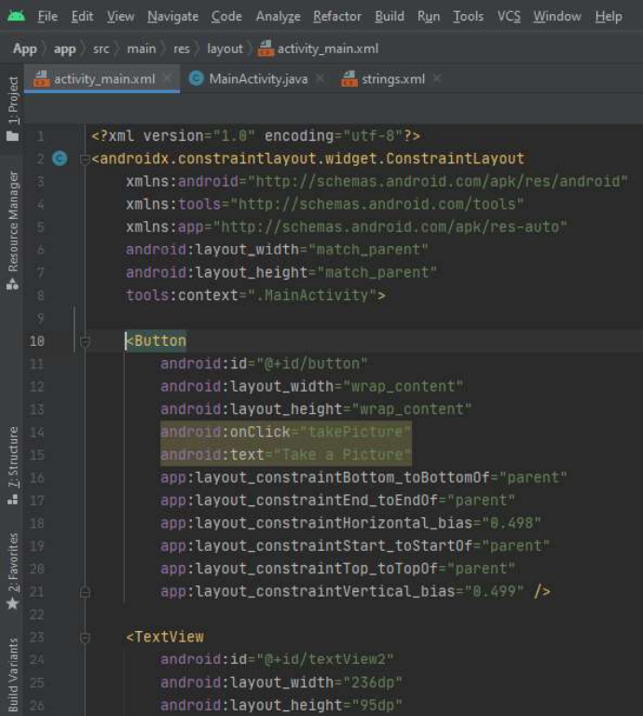

# OUTPUT of camera access:

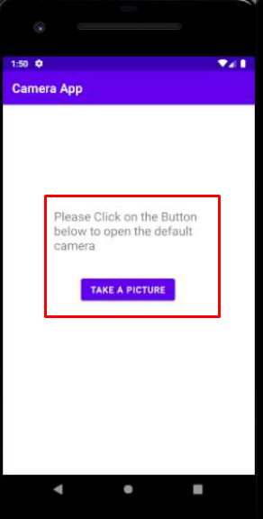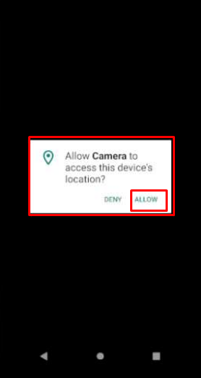

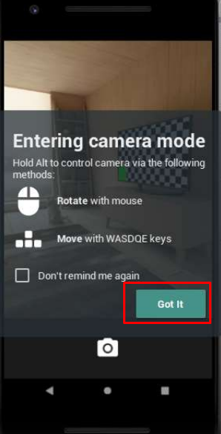 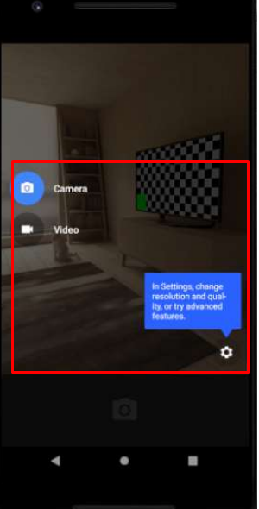  
--------------------------------------------------------------------------------------------------------------------------------



**SKILL JOURNAL**

Enrollment Number – 2019BTCS088 Year of Enrollment – 2019

Name of the Student – YASH GUPTA

School of COMPUTER SCIENCE & INFORMATION TECHNOLOGY

Program – B. TECH

Specialization/ Branch – CS&IT

Semester – 4TH Section – B2 Branch – CS&IT

Paper Code – BTCS04CCB4 Name of Paper – Mobile Application Development

Faculty-In-Charge – MR. DEEPAK YADAV SIR

CERTIFICATE

THE SKILL EXPERIMENTS

ENTERED IN THIS JOURNAL HAVE BEEN SATISFACTORY PERFORMED BY

ENROLLMENT NO - 2019BTCS088 MR/MS­­­­­­­­­­­­­­­­­­­­ YASH GUPTA

STUDYING IN PROGRAM B. TECH BRANCH CS&IT IN

SCHOOL OF COMPUTER SCIENCE & INFORMATION TECHNOLOGY

DURING SEMESTER 4TH OF ACADEMIC YEAR 2020-2021

_______________________

(Faculty in charge)  
Date: _________________

INDEX

|  |  |  |  |  |
| --- | --- | --- | --- | --- |
| S.NO | Title of Skill Activity | Date of Allocation | Date of Submission | Sign of Faculty |
| 1 | Create a Mobile Android Application that consists of Layout, UI Elements, Menu Activities etc. uses SQLite Database to store the data. | 14/06/2021 | 30/06/2021 |  |
|  |  |  |  |  |
|  |  |  |  |  |
|  |  |  |  |  |
|  |  |  |  |  |
|  |  |  |  |  |
|  |  |  |  |  |
|  |  |  |  |  |
|  |  |  |  |  |
|  |  |  |  |  |
|  |  |  |  |  |
|  |  |  |  |  |
|  |  |  |  |  |
|  |  |  |  |  |
|  |  |  |  |  |
|  |  |  |  |  |
|  |  |  |  |  |
|  |  |  |  |  |
|  |  |  |  |  |
|  |  |  |  |  |
|  |  |  |  |  |
|  |  |  |  |  |
|  |  |  |  |  |
|  |  |  |  |  |
|  |  |  |  |  |
|  |  |  |  |  |
|  |  |  |  |  |
|  |  |  |  |  |
|  |  |  |  |  |
|  |  |  |  |  |
|  |  |  |  |  |
|  |  |  |  |  |
|  |  |  |  |  |
|  |  |  |  |  |
|  |  |  |  |  |

SKILL ACTIVITIY NO: 1  
(To be filled by the students)

Date: 14th June 2021

**(To be filled by Faculty)**

|  |  |  |
| --- | --- | --- |
| Sr. No. | Skill /Competencies | (Achieved / Not Achieved)  (Yes / No) |
|  |  |  |
|  |  |  |
|  |  |  |
|  |  |  |

Remarks :

Total mark ___________________________out of 10.

Signature of Faculty

Date: _________________

**Details of Activity:**

# source code: QUestion 1

**File Name: WebFormFirst.aspx**

**File Name: WebFormFirst.aspx.cs**

**File Name: WebFormSecond.aspx**

**File Name: WebFormSecond.aspx.cs**

**File Name: WebFormThird.aspx  
  
  
File Name: WebFormThird.aspx.cs**

# output:

------------------------------------------------------------------------------------------------------------------------------------------------------------